Test 4:

numplants = 167

targetsize = (300,300)

batchsize = 32

epochs = 100

Model: "sequential"

__

Layer (type) Output Shape Param #

=================================================================

efficientnet-b3 (Model) (None, None, None, 1536) 10783528

__

global_averagepooling2d (Gl (None, 1536) 0

__

dense (Dense) (None, 2048) 3147776

_

dense1 (Dense) (None, 1024) 2098176

__

dense_2 (Dense) (None, 167) 171175

=================================================================

Total params: 16,200,655

Trainable params: 16,113,359

Non-trainable params: 87,296

72/72 [==============================] - 96s 1s/step - loss: 1.8357 - accuracy: 0.5551

test acc: 0.55512154

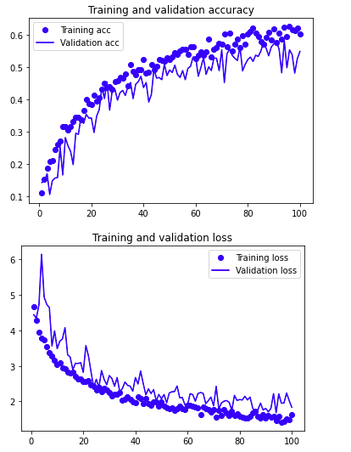

Conclusion: Accuracy was bad. Trying a deeper model. Going to test a different convolution base.